Twitter posts:

Standards:

#schoollibrarians support #ESSA bc we know/support standards like ELA CCSS & DLCS @MASchoolsK12 Ex: http://bit.ly/MAk5lib #MSLA

#schoollibrarians support #ESSA -teach Ss to use access, use, cite online databases: http://bit.ly/MAdatabases #MSLA @MASchoolsK12

#schoollibrarians support #ESSA bc we teach #digicit as part of MA DLCS #standards #MSLA @MASchoolsK12

#schoollibrarians support #ESSA bc we are partners to Ts in supporting high quality #research #collaboration @MASchoolsK12 #MSLA

Accountability:

#schoollibrarians support #ESSA --offer #personalizedlearning, #equity in access to digital/print resources on diff rdg levels @MASchoolsK12

#schoollibrarians support #ESSA --studies show certified #schoollibrarian impacts #studentachievement @MASchoolsK12 https://goo.gl/QcHfaa

#schoollibrarians support #ESSA - we train and support Ts and Ss to live in a #globaled #digital world @MASchoolsK12 #MSLA

#schoollibrarians support #ESSA - put a school librarian in every MA school -see test scores rise! #studentachievement @MASchoolsK12 #MSLA

Innovation:

#schoollibrarians support #ESSA - offer school/district wide PD in #edtech #digicit #makerspace #inquiry #literacy #PBL @MASchoolsK12 #MSLA

#schoollibrarians support #ESSA --offer opportunities 4 #innovation #collaboration #creativity #makerspace // @MASchoolsK12 #MSLA

#schoollibrarians support #ESSA with family #collaboration to celebrate/inform #literacy #digicit #makerspace @MASchoolsK12 #MSLA

#schoollibrarians support #ESSA with family #collaboration to celebrate/inform #literacy #digicit #makerspace @MASchoolsK12 #MSLA

SEI/Whole Child:

#schoollibrarians support #ESSA and the whole child - libraries are safe refuges for Ss #bibliotherapy #MSLA @MASchoolsK12

#ESSA is an opportunity to put a school librarian in every school - let’s make MA more equitable! All Ss deserve a school library. #MSLA @MASchoolsK12

#schoollibrarians support #ESSA & whole child - #digicit skills, #reading, #edtech, #makerspace #personalizedlearning #MSLA @MASchoolsK12

FB/Instagram post:
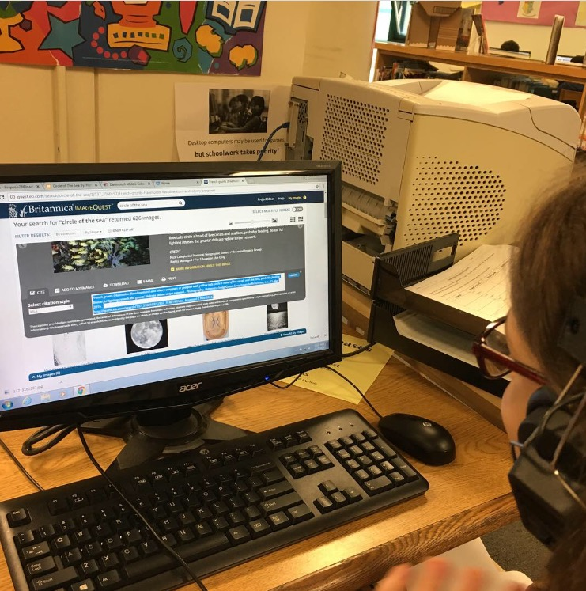
#schoollibrarians support #ESSA by teaching #standards, teaching ethical use of digital resources (citation!) like the one pictured above and much, much more.

